Title: | Linux Fundamentals for DevOps
Updated: | April 3, 2025 | Due Date: | Midnight before the next class meeting.
Purpose: | The purpose of this lab is to provide hands-on experience with essential Linux commands and system management techniques critical for DevOps roles, including file system navigation, user management, networking, and package installation, to enhance students' ability to efficiently manage cloud infrastructure and automation processes.  This lab addresses competency 2 – perform basic Linux tasks.
Knowledge: | Upon completing this lab, you will have a foundational understanding of Linux commands, file system management, user permissions, networking, and package installation relevant to DevOps environments.
Task/Activity: | A. Introduction to Linux  B. Navigating the Linux File System  C. Essential Linux Commands for DevOps  D. User and Permission Management  E. Networking Basics in Linux  F. Package Management and Software Installation  G. Reflection
Criteria for Success: | Success in this lab is marked by accurate task completion, effective analysis, documentation, and clear communication of findings. A crucial aspect involves reflecting on the purpose of the lab, linking procedures to broader concepts, and recognizing the lab's significance within the course.  Overall, success is not only measured by technical proficiency but also by critical thinking, effective communication, and a reflective summary that captures the challenges faced and insights gained throughout the lab experience.
- Introduction to Linux
Linux is a free, open-source operating system that is widely used in DevOps environments due to its stability, flexibility, and security features. Unlike proprietary systems like Windows, Linux allows users to modify and distribute its code, which is essential for developers and operations teams (hence "DevOps") working together to manage infrastructure. In DevOps, Linux powers most cloud platforms, servers, and tools that automate deployment, testing, and monitoring processes. Understanding Linux basics is crucial for anyone entering this field, as most DevOps tools are Linux-based or designed to work well with it.
- Research and briefly explain the advantages of using Linux in a DevOps environment over other operating systems.
Some of the best advantages when using Linux in a DevOp environment is the open-source nature of Linux. As an operating system Linux allows for scalability and performance meaning devs are able to run critical apps and services. The compatibility with cloud computing and the open-source capability, makes the operating system a hub for creating systems that fit the various needs of the DevOps environment/
- Have you used Linux in the past? If so, where and how much?
I have limited experience with Linux, using it mainly to set up my database in a previous class. I used Linux at the beginning of my database administration class.
- Navigating the Linux File System
The Linux file system is organized in a hierarchical structure, starting from the root directory (/).
This is where I feel the need to strongly emphasize something that many students are confused by when starting to learn Linux.

There are THREE different “root” terms in Linux.
1. The root user – This is the administrator account.
2. The root filesystem – This is the / of the filesystem hierarchy. Think of this as C:\> in Windows.
3. The root home folder – This is the home folder of the root user, located in the root of the filesystem. It is located at /root.

If I ask you to login as root, this is logging in as the admin account.
If I ask you to go to the root of the system, it is /.
If I ask you to go to the root home folder or ~ as root, you should go to /root.
This structure helps users and applications access files systematically. Common directories include /bin (binary executables), /etc (configuration files), /home (user home directories), and /var (variable data like logs). Understanding where files are stored and how to navigate the file system using terminal commands is vital for managing servers. Commands like ls (list files), cd (change directory), and pwd (print working directory) are foundational tools for interacting with the system.
Here is another representation of the Linux filesystem:
/
├── bin - Essential binaries (e.g., ls, cp)
├── boot - Bootloader files (e.g., kernel, initramfs)
├── dev - Device files (e.g., /dev/sda)
├── etc - System configuration files
├── home - User home directories
│ ├── user1
│ └── user2
├── lib - Shared libraries for essential binaries
├── media - Mount points for removable media
│ ├── usb
│ └── dvd
├── mnt - Temporary mount points
├── opt - Optional software packages
├── proc - Kernel and process information (virtual filesystem)
├── root - Home directory for the root user
├── run - Runtime data for processes
├── sbin - System binaries (e.g., reboot, fdisk)
├── srv - Data for services (e.g., web server files)
├── sys - Kernel and hardware information (virtual filesystem)
├── tmp - Temporary files (cleared on reboot)
├── usr - User programs and data
│ ├── bin - User binaries
│ ├── lib - Shared libraries for user binaries
│ ├── share - Shared resources (e.g., man pages)
│ └── local - Locally installed software
└── var - Variable files (e.g., logs, cache, spool)
├── log - Log files
├── cache - Application caches
└── spool - Queued tasks (e.g., mail, printing)
To navigate between the folders, the cd (or change directory) command is used. You can use a relative path or absolute path with cd. For example, in the list above, if you were in /var/log and wanted to navigate into /home/user1, you could use any of these commands and get there:
# cd /home/user1 ß This is the absolute path (1 command)
# cd ../../home/user1 ß This is the relative path (1 command)
# cd ..
# cd .. ß This is the longest way and is relative each step (4 commands)
# cd home
# cd user1
- Connect to your Linux instance and navigate to the /etc directory.
Type in command used: cd /etc
Now that we are in a folder, we probably want to see what is in there. To do this, we will use the ls (list) command. By itself, ls will show the contents of the directory you are in.
# ls
alternatives apt bash.bashrc cron.d cron.weekly default fstab hostname
bashrc bind crontab cron.daily debconf.conf dhcp group hosts
ca-certificates cron.hourly cron.monthly depmod.d dnsmasq.d gshadow init.d
cron-apt dbus-1 default environment hostname inputrc issue ld.so.conf.d
This is great if we want a list of files, but we might want to know more about the files like ownership, permissions, date, hidden files and size. To do this, we need to modify ls to add -la (-l is to show detailed information, -a is to show all files, including hidden files).
# ls -la
drwxr-xr-x 2 root root 4096 Dec 28 10:00 alternatives
drwxr-xr-x 3 root root 4096 Dec 28 10:00 apt
drwxr-xr-x 2 root root 4096 Dec 28 10:00 cron.d
drwxr-xr-x 2 root root 4096 Dec 28 10:00 cron.daily
…
- List all the files inside /etc and identify at least two configuration files. (Hint: .conf files)
Type in command used: ls -la
List two configuration files: yum,conf -> dnf/dnf.conf and xattr.conf
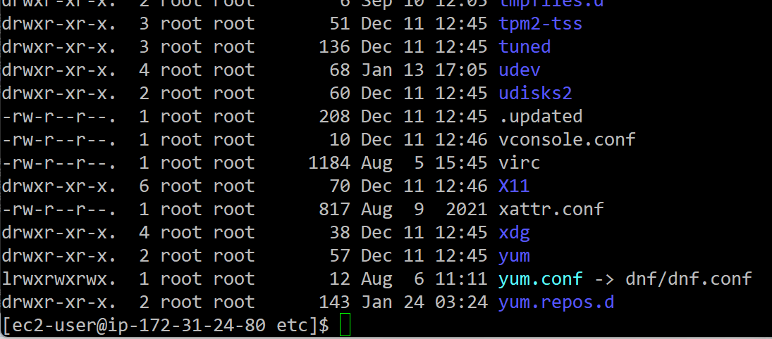
There is a special character that you can use to navigate to the home folder without having to type all the entire path (or even know the path!). When paired with the cd command, ~ substitutes the home folder.
# cd ~ ß This will take you to your home directory (usually /home/username if user, or /root if root)
# cd ~username ß This will take you to the home directory of the user that you specified
# cd ~jbob would take you to /home/jbob (if that is their home folder)
Now that you know how to move around the folders, you can create some files and folders. To create a blank file, you can use the command touch:
# touch filename.txt ß This will create a file called filename.txt
If you want to create a file and edit it at the same time, you can use several text editors to do this on Linux. The one tool that is on every Linux version is called vi. A lot of people dislike vi as it is not very easy to navigate and use, if you don’t know all the “secret” ways. You can open a new file with vi like so:
# vi newfile.txt
This will open the vi editor, editing the newfile.txt file. You may notice that you are not able to type anything in the window that shows up. That is because you need to enter INSERT mode to insert text into the file (or make changes). To enter INSERT mode, simply type the i key (for insert). You can then type into the file, make new lines, delete things, etc.
When you are done editing the file, press the ESC key to exit INSERT mode. At this point, you will want to save and exit the file, which you can do with:
:wq ß The : enters the command mode, w writes the file to disk (saves), and q quits.
If you want to discard your changes, you can modify the command to:
:q! ß The ! forces vi to quit without saving.
We can navigate folders, and create files, but what about creating folders? We can do that with the mkdir (make directory) command:
# mkdir newfolder
This will create a new folder in your current folder called newfolder. If you wanted to create a folder inside of that folder, you could navigate into it (with cd), or you could:
# mkdir newfolder/subfolder
Finally, if you wanted to skip a step, you could create both folders at once:
# mkdir -p newfolder/subfolder
- Navigate to your home directory and create a new directory named devops_practice.
Type in commands used:
cd
sudo mkdir devops_practice
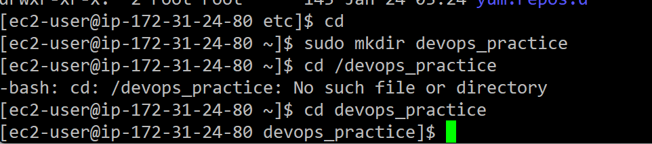
- Essential Linux Commands for DevOps
To manage infrastructure and applications, DevOps engineers rely heavily on Linux commands. Some fundamental commands include cp (copy files), mv (move files), rm (remove files), and chmod (change file permissions). Additionally, understanding process management using commands like ps, top, and kill is critical for handling running applications. For DevOps automation, scripts are often written using the shell scripting language (like Bash), where commands are used in scripts to automate routine tasks such as backups, updates, and monitoring.
To work on this section of the lab, run the following command in your home folder on your Linux instance:
# sudo curl -sSL https://webandsoftware-online.s3.us-east-005.backblazeb2.com/devops/linux/lab03-setup.sh | bash
This command downloads a script file from the internet, and runs the mkdir and touch commands to create the folders and files needed to complete this lab. To help visualize the structure, download a tool called tree which shows a more “graphical” view of the files and folders, and run it to see what folders and files have been setup:
# sudo dnf -y install tree
# tree
.
├── devops
│ ├── Markdown Basics
│ │ └── README.MD
│ └── lab1
│ └── TOC.MD
└── lab03
├── folderA
│ ├── fileA
│ ├── fileB
│ └── fileC
├── folderB
└── folderC
- Navigate into the lab03 folder in your home directory.
Write the command you used here.
cd lab03
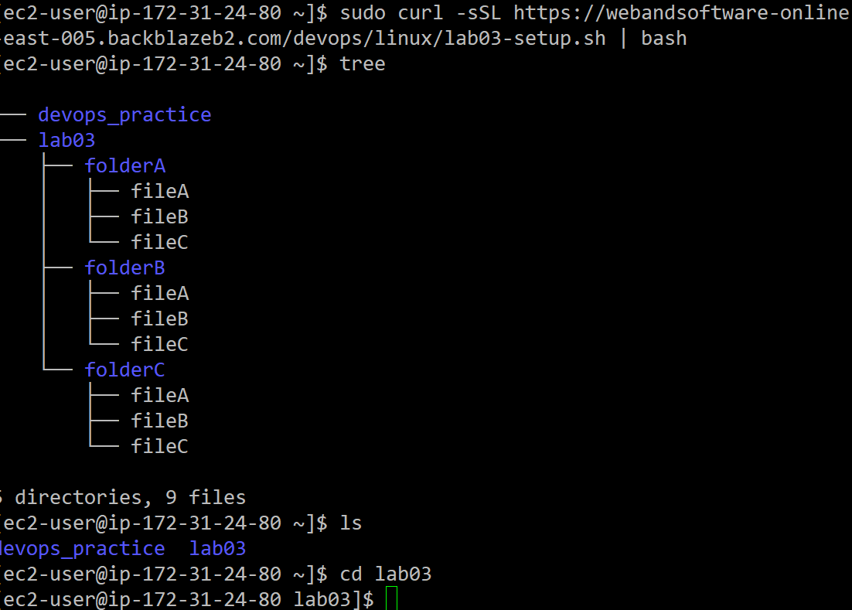
Now that we have the files and folders needed, we can learn about managing files. In Linux, files are moved, copied, and deleted (or removed) all the time. The first tool we are going to learn is cp (copy). To copy a file, simply run the cp command with the source file name, followed by the destination file name.
# cp original_file.txt new_file.txt
- Let’s create a couple of files to work with in the lab03 folder. Create two files (using the touch command we learned in the previous section) named file1 and fileA.
Write the commands you used to complete this here.
touch file1.txt
touch fileA.txt
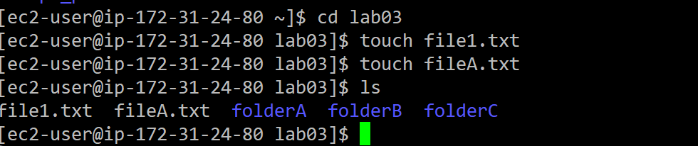
- Use the cp command to copy file1 to create file2 and file3. Use the tree command to verify creation. Attach a screenshot of the tree command below.
Write the commands you used here.
cp file1.txt file2.txt
cp file1.txt file 3.txt

Paste screenshot here
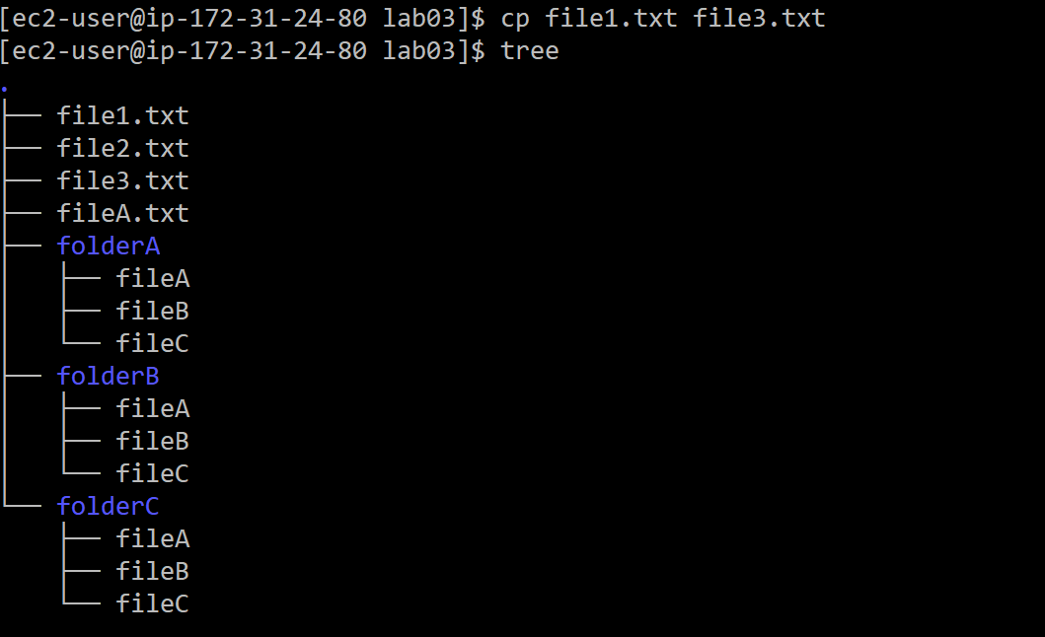
Now that we have some files to play with, we can use other file commands to modify or delete them. To rename a file, use the mv (move) command. It may seem strange to use a move command to rename something, but in a way the file is being moved from the original name to the new name.
# mv original_file.txt renamed_file.txt
- Rename file2 to fileB and file3 to fileC. Use the tree command to verify. Attach a screenshot below.
Write the commands you used here.
mv file2.txt fileB.txt
mv file3.txt fileC.txt
Paste screenshot here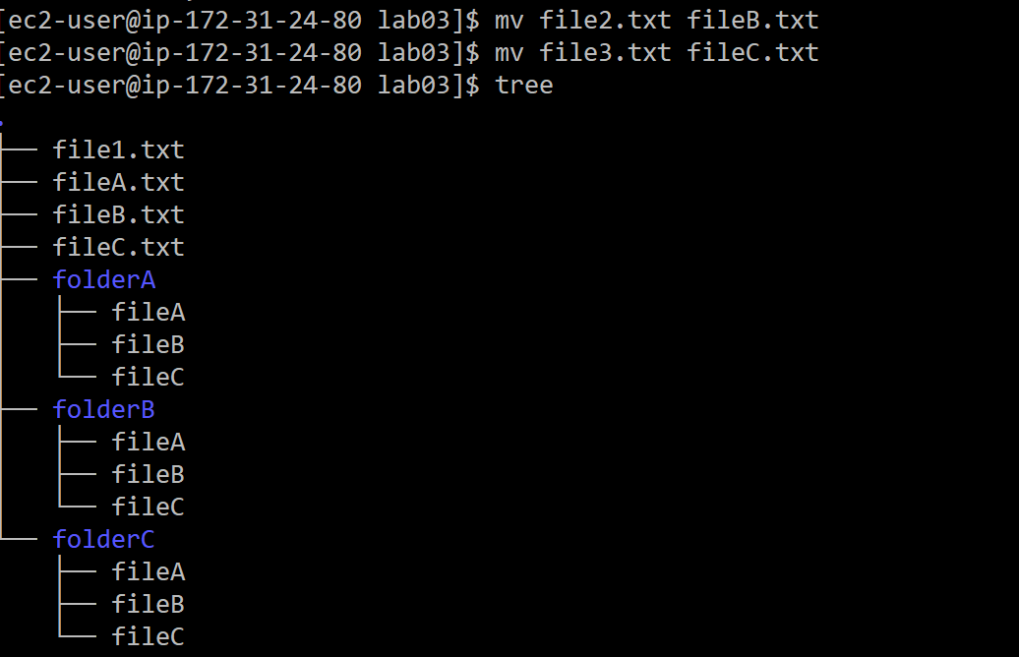
As you can see from the tree output, there are three files in the folderA directory. What if we wanted to copy those files to folderB and folderC? We could use the cp command one at a time:
# cp folderA/fileA folderB/fileA
# cp folderA/fileB folderB/fileB
…or – we could use a wildcard character. In most operating systems, the asterisk (*) acts as a wildcard to represent zero or more characters in file or directory names. For example, *.txt matches all files with a .txt extension, and file* matches any file starting with "file". A much more efficient way to copy the files would be:
# cp folderA/file* folderB/
- Copy all the files from folderA into folderB and folderC. Run tree to verify.
Write the commands you used here.
cp folderA/file* folderB/
cp folderAfile* folderC/
Paste screenshot here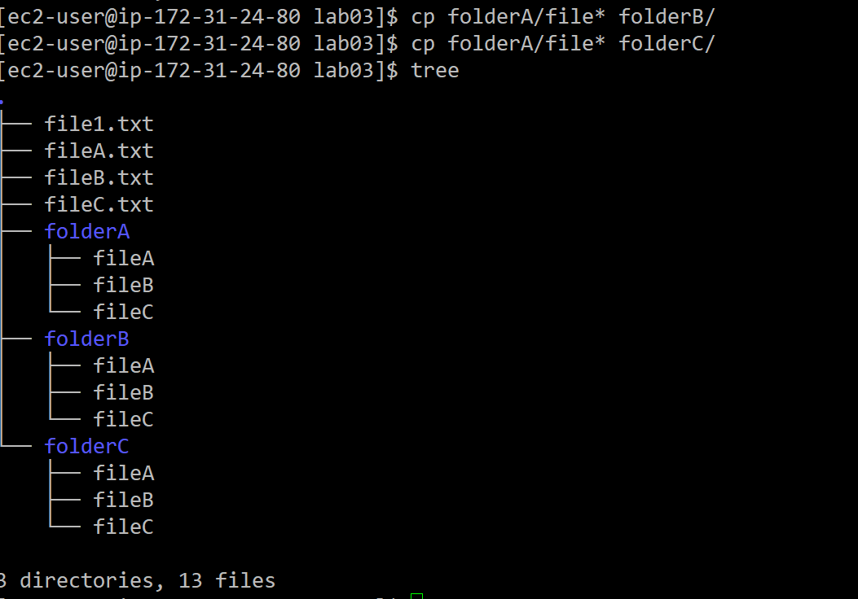
We can create files and folders, copy, rename, and move them. How about deleting them? For that, we use the rm (remove) command. rm can delete files and folders. To delete files, you can run it like so:
# rm file1
- To delete a folder, it is a little more complicated. Try running rm folderA. What happened?
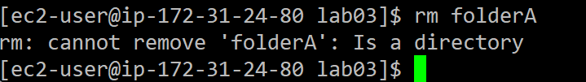It gave an error message stating that ”folderA” is a directory.
There are a couple of stumbling blocks that rm has with folders. First, if a folder is not empty, it will not allow deletion. To verify this, run:
# rm -d folderA
The -d flag tells rm to delete a folder.
- What happened?
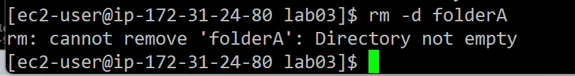
It will not delete since the folder is not empty.
If we want to delete a folder, we can either remove the files inside of it first, then run the rm -d command again:
# rm folderA/*
# rm -d folderA
- Run those commands. Was it successful? Run tree and provide a screenshot below:
Answer
rm folderA/*
rm –d folderA
Screenshot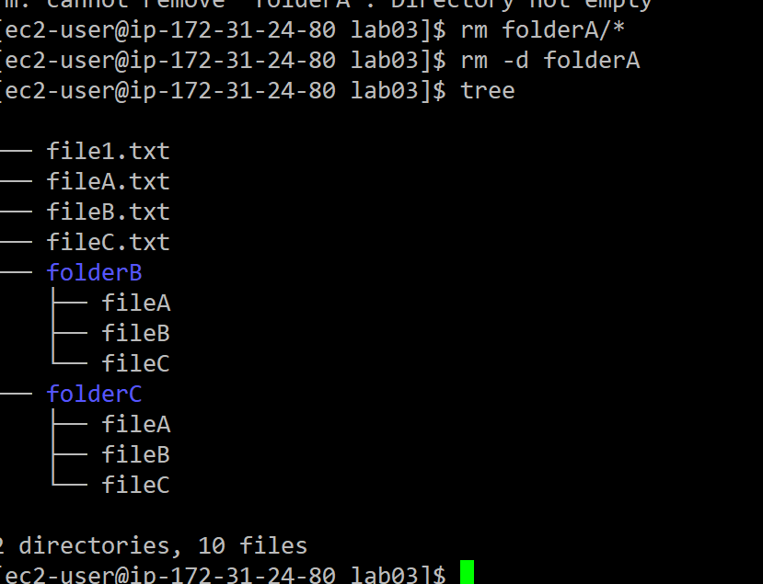
The other way is to brute force the deletion. This command is very powerful and if not done properly, could result in your system being completely unusable. rm has the -r (recursive – or go through all the files and folders under this folder and wipe it all out) and -f (force – do not prompt for verification).
- To remove folderB, along with all the files and folders in folderB, run:
# rm -rf folder
Run this command and provide the output of tree below.
Insert screenshot here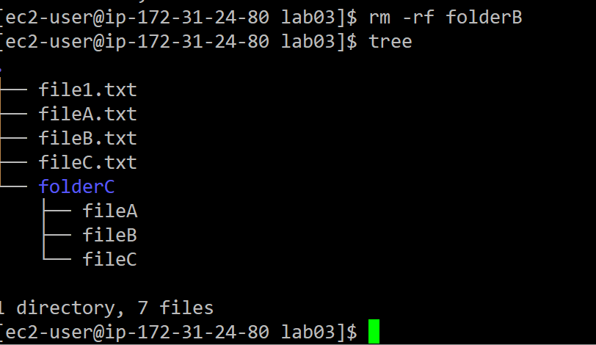
There is a common “solution” online that trolls will often post when helping new Linux admins:
# sudo rm -rf /
DO NOT RUN THIS COMMAND. This will delete every file, folder, and device from your Linux machine, making it inoperative. This rm command deletes everything starting in the root file system (/).
- Recreate the following file and folder structure in your lab03 folder.
Structure to recreate | Commands to recreate | Screenshot of tree command after
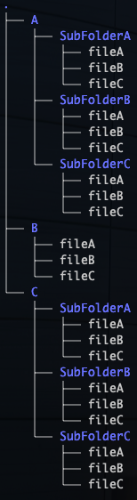 | mkdir A  mkdir B  mkdir C  cd A  mkdir SubFolderA  mkdir SubFolderB  mkdir SubFolderC  cd SubFolderA  touch fileA  touch fileB  touch fileC  cp SubFolderA/file* SubFolderB  cp SubFolderA/file* SubFolderC  cd  cd lab03  cd B  touch fileA  touch fileB  touch fileC  cd  cd lab03  cd C  mkdir SubFolderA  mkdir SubFolderB  mkdir SubFolderC  cd SubFolderA  touch fileA  touch fileB  touch fileC  cp SubFolderA/file* SubFolderB  cp SubFolderA/file* SubFolderC | 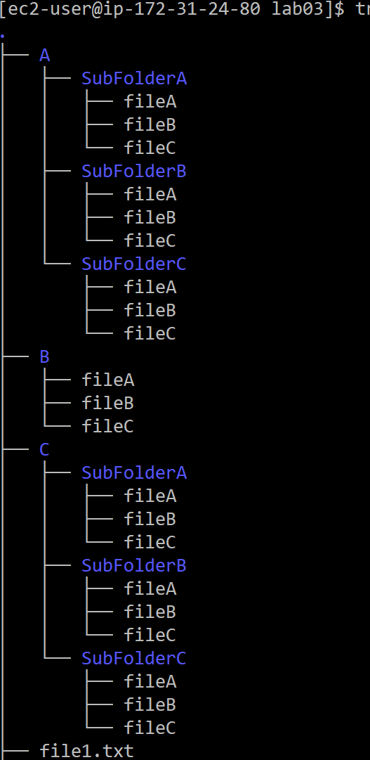
- User and Permission Management
User and permission management is a key responsibility in any Linux environment, especially when working on cloud servers or CI/CD pipelines. Each user on the system has an account, a user ID (UID), and belongs to one or more groups, which determine access permissions to files and processes.
A common task on a Linux machine is adding, modifying, and deleting users. To add a user, we use the adduser command:
# sudo adduser {username}
This will create the user specified in the {username} section of the command. This doesn’t do anything else that special, just creates the user. Usually, we want to specify a name to go along with the user account. To do that, we add the -c flag to the command:
# sudo useradd bushmant -c “Tage Bushman”
This will associate the full name with the new user. We can see this by looking at the /etc/passwd file that lists the account, name, UID, GUI, and shell for each user. To look at this in the shell, we can use a handy tool called cat (concatenate and print the output):
# cat /etc/passwd
ec2-instance-connect:x:993:993::/home/ec2-instance-connect:/sbin/nologin
rpcuser:x:29:29:RPC Service User:/var/lib/nfs:/sbin/nologin
tcpdump:x:72:72::/:/sbin/nologin
ec2-user:x:1000:1000:EC2 Default User:/home/ec2-user:/bin/bash
bushmant:x:1001:1001:Tage Bushman:/home/bushmant:/bin/bash
We have the user created, but we still need to specify the password. The passwd command is used for that:
# sudo passwd bushmant
Changing password for user bushmant.
New password: student2025 ß Note that nothing will appear when you enter the password. This is a security feature.
Retype new password: student2025
passwd: all authentication tokens updated successfully.
- Create a new user on your Linux system named devops_user, with the full name of “DevOps User.”
Enter command here. sudo adduser devops_user -c "DevOps User"

- Set the password for the devops_user account to student2025.
Enter command here. sudo passwd devops_user student2025

Now that we have a user to work with, we can create a group that the user can be a part of. To do this, the groupadd command will be used.
# sudo groupadd admins
This will create a group called admins that users can be assigned to.
Another benefit of groups is the ability to assign permissions to a group instead of a single user. This makes administration much easier. When a new employee is hired and needs access, they can be added to the group – which already has all the proper permissions. No need to add the user to each file and folder individually. This also makes it easier to remove permissions from users who change roles, or leave the company.
- Create a group called devops to add all DevOps users to.
sudo groupadd devops
To add users to the group, the usermod command can be used. There are a lot of options for usermod, which you can see by typing usermod with no arguments. To add a group to a user:
# sudo usermod {username} -aG {groupname} ß Notice that the G is capitalized
- Add the devops_user to the devops group.
sudo usermod devops_user -aG devops

Permissions are defined by read, write, and execute flags for the file owner, group, and others. Commands like useradd, passwd, chmod, and chown (change ownership) are essential for managing access control in multi-user environments.
The following chart depicts three (of the four) octal modes for file permissions. The fourth is for setuid, setgid, and sticky flags – which will be covered later. Of the three octal modes, read (r), write (w), and execute (x) can be selectively set for the user of the file, the group assigned to the file, and to ALL others on the system that are not considered the user or part of the group. In the given chart, the chmod mode is 754, which means the user can read, write, and execute the file (4+2+1), the group can only read and execute (4+1), and all others on the system can only read (4) the file.

r | w | x | r | - | x | r | - | -
User Permissions |  |  | Group Permissions |  |  | Other Permissions
4 | 2 | 1 | 4 | 2 | 1 | 4 | 2 | 1
7 |  |  | 5 |  |  | 4
This is a very important chart that I recommend you know and understand.
To change the permissions on a file or folder, we will use the chmod (change mode), and chown (change owner) commands. Looking at the chart above, to set the permissions of the lab03 subfolder A to rwx (read, write, and execute) for the user, r (read) for the group, and no permissions for other, the following command would be used:
# cd ~lab03 ß Make sure we are in the correct folder
# sudo chmod 740 A
Run the ls -la command to see the permissions:
# ls -la
total 16
drwxr-xr-x. 6 ec2-user ec2-user 87 Dec 30 20:45 .
drwx------. 8 ec2-user ec2-user 16384 Dec 30 20:19 ..
drwxr-----. 5 ec2-user ec2-user 60 Dec 30 20:05 A
drwxr-xr-x. 2 ec2-user ec2-user 45 Dec 30 20:06 B
Compare the two highlighted sections. Notice that folder A now has the rwx, r, nothing permissions, where folder B has rwx, rx, and rx. Our permissions have been successfully changed.
This would be a good time to look at the output of the ls -la command and explain what we are seeing:
total 16
drwxr-xr-x. 6 ec2-user ec2-user 87 Dec 30 20:45 .
drwx------. 8 ec2-user ec2-user 16384 Dec 30 20:19 ..
drwxr-----. 5 ec2-user ec2-user 60 Dec 30 20:05 A
drwxr-xr-x. 2 ec2-user ec2-user 45 Dec 30 20:06 B
The green highlighted sections are the permissions for the file/folder. The first letter is d – marking it as a directory. The next 9 characters are the rwx values for the user, group, and other.
The light blue is the number of hard links to the file or directory. This is not important for us at this point.
The dark blue is the user who owns the file or folder.
The red is the group who owns the file or folder. Note that by default a group is created with the same name as the user and is set as the owner and group (by default) of any new files or folders created by that user.
The yellow is the size (in bytes) of the file or folder. You can see this in more “human readable” sizes by adding -h to the ls -la command.
The darker green (teal?) is the date the file was last modified.
The unhighlighted last column is the name of the file or folder.
To target a specific part of chmod without changing the other values, user (u), group (g), and other (o) can be specified. To change the group permissions only to read and execute:
# sudo chmod g=rx {folder or file}
This will leave the other permissions unaffected.
- To change the owner, use the chown command to change the owner on the devops_practice directory to devops_user:
# sudo chown devops_user devops_practice
Verify the change by running ls -la
Attach screenshot here 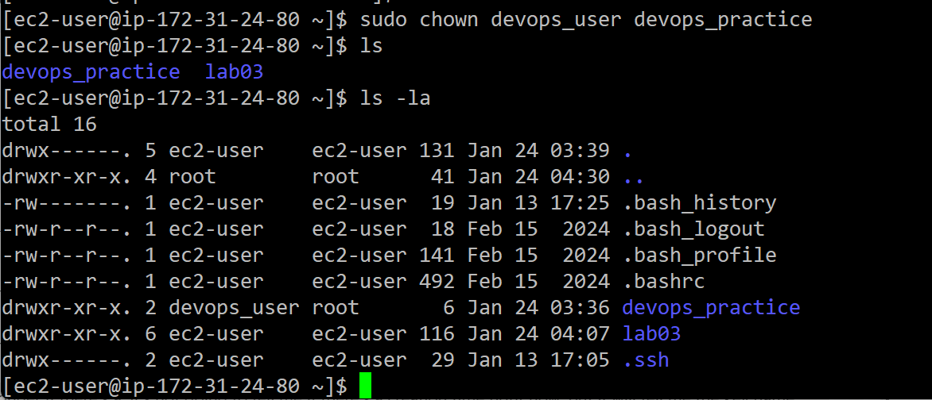
- Modify the user’s permissions to grant them read and execute access to the devops_practice directory created earlier.
sudo chmod u=rx devops_practice

Finally, to change the group, the chgrp command. It works very much like the chown command.
- Change the group owner of devops_practice to devops. Verify the changes by listing the permissions using the ls -l command and providing a screenshot.
Command used sudo chgrp devops devops_practice

Screenshot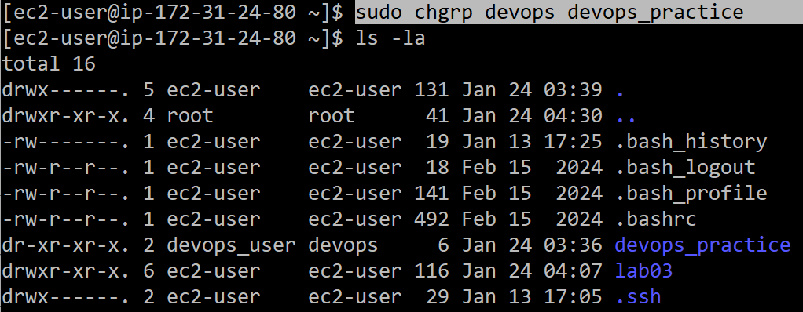
- Networking Basics in Linux
Linux servers often function as critical network components, running services like web servers, DNS, or databases. Understanding basic networking commands is important for setting up environments and troubleshooting. The ifconfig or ip commands allow you to check and configure network interfaces, while ping tests connectivity. Other commands like netstat and ss help monitor network connections, and curl or wget are used to transfer data over networks, commonly in DevOps pipelines.
- Use the ifconfig or ip addr command to display your system’s network configuration.
IP Address | 172-31-24-80
Screenshot of output | 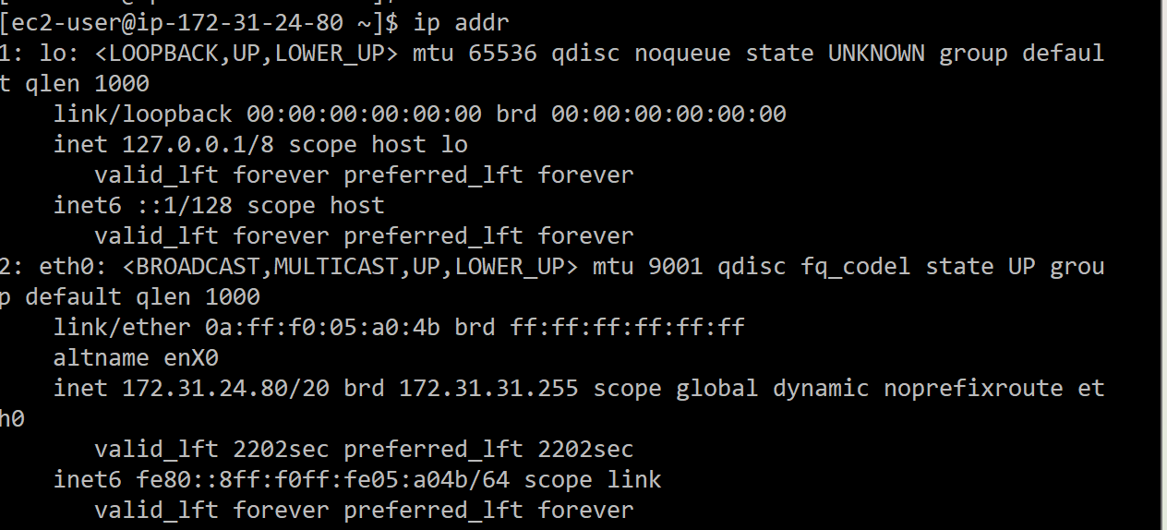
- Test the network connectivity to a website like google.com using the ping command.
Attach screenshot 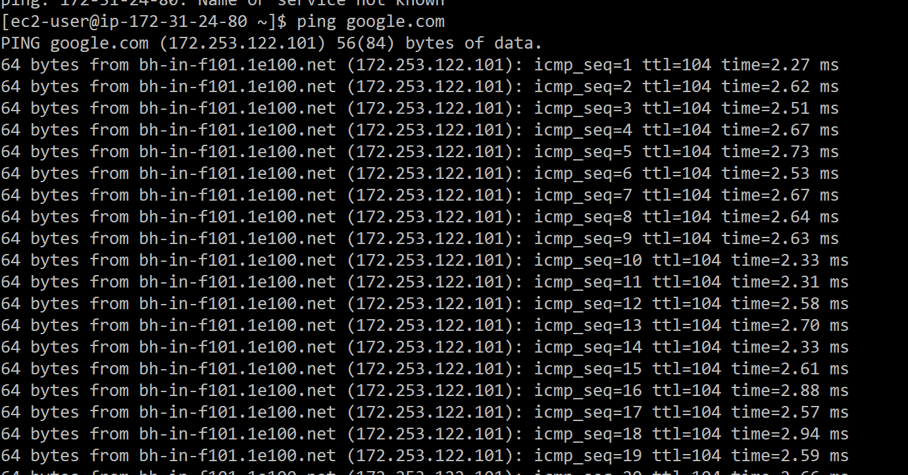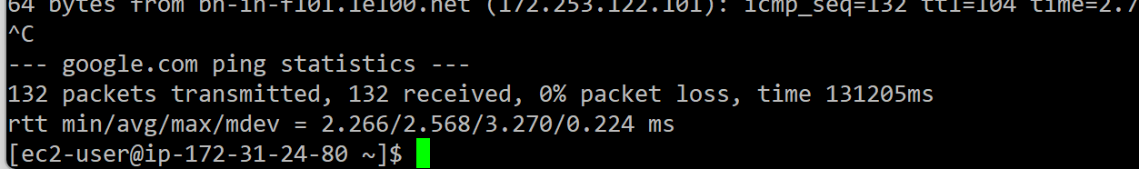
One of the most useful set of commands to download files to a Linux machine using the command line only are curl (client URL), and wget (web get). Both support different protocols like HTTP, HTTPS, and FTP. wget is used only for downloading files, where curl can be used to send and receive data. Simply type the command followed by the file that you want to download:
# wget {URL}
- Download a file from the internet (https://cyber-online.s3.us-east-005.backblazeb2.com/linux-admin/sample1) using curl or wget and display the output of the command.
curl https://cyber-online.s3.us-east-005.backblazeb2.com/linux-admin/sample1
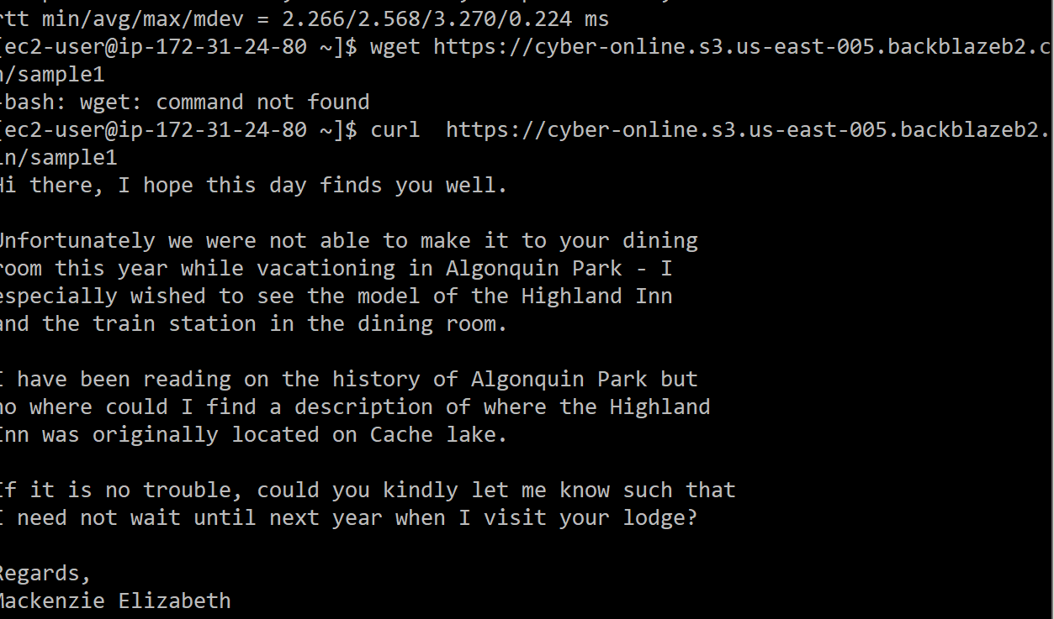
- Package Management and Software Installation
Managing software on Linux is streamlined through package management systems. Distributions like Ubuntu use apt, while CentOS and Red Hat use yum or dnf. DevOps tools, frameworks, and dependencies are installed and updated via these package managers. Commands like apt-get install, apt update, and apt upgrade allow for easy software management, ensuring servers have the correct and latest software versions installed. Understanding package management is vital for maintaining stable and secure environments.
Since we are using the Red Hat for out Linux server, we will use dnf in place of apt-get (or simply apt in newer versions). Most commands can just replace apt-get or apt with dnf to work properly.
On a new Linux system, and periodically on an older system, updates should be run to keep the system secure and stable. To do this, the dnf update and dnf upgrade commands are used.
# sudo dnf update ß This updates the list of packages (software) available to install or update
# sudo dnf upgrade ß This will upgrade any out of date packages on your system to the latest version.
Note that upgrading software in a production environment could be dangerous. Make sure that you have a development environment that matches production to run updates on and test for issues before updating. Use of tools like Docker (which we will cover soon) help mitigate these issues.
- Install the nginx web server on your system using your distribution's package manager (e.g., sudo apt install nginx or sudo dnf install nginx).
sudo dnf install nginx
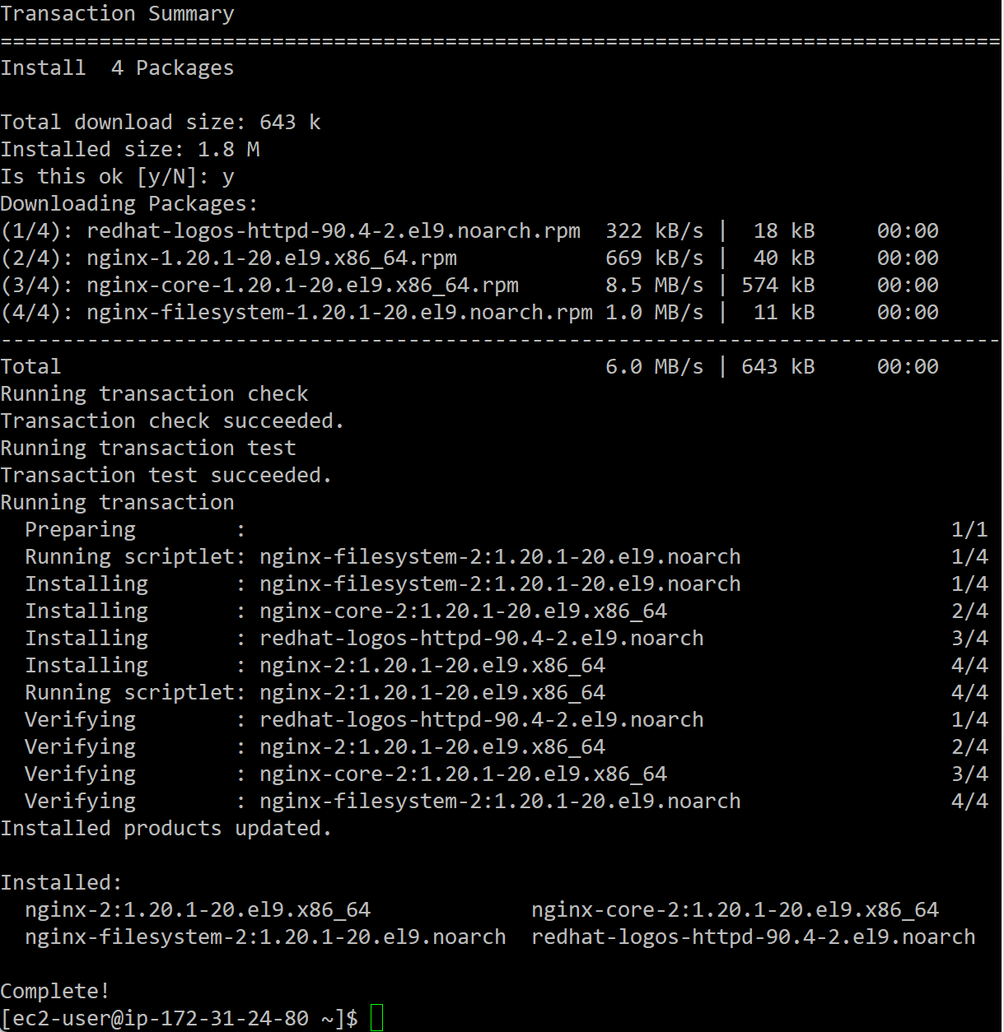
Most software that runs as a service need to be enabled so on boot it will start, then must be manually started for the first time. This is done with the systemctl (System Control) command.
# sudo systemctl enable nginx
Created symlink /etc/systemd/system/multi-user.target.wants/nginx.service → /usr/lib/systemd/system/nginx.service.
# sudo systemctl start nginx
To verify that the service has started and is running, the status flag can be used:
# sudo systemctl status nginx
● nginx.service - The nginx HTTP and reverse proxy server
Loaded: loaded (/usr/lib/systemd/system/nginx.service; enabled; preset: disabled)
Active: active (running) since Mon 2024-12-30 21:32:46 UTC; 4s ago
Process: 8507 ExecStartPre=/usr/bin/rm -f /run/nginx.pid (code=exited, status=0/SUCCESS)
Process: 8508 ExecStartPre=/usr/sbin/nginx -t (code=exited, status=0/SUCCESS)
Process: 8509 ExecStart=/usr/sbin/nginx (code=exited, status=0/SUCCESS)
Main PID: 8510 (nginx)
Tasks: 2 (limit: 1111)
Memory: 2.4M
CPU: 38ms
CGroup: /system.slice/nginx.service
├─8510 "nginx: master process /usr/sbin/nginx"
└─8511 "nginx: worker process"

Dec 30 21:32:46 ip-172-31-31-177.ec2.internal systemd[1]: Starting nginx.service - The nginx HTTP and reverse proxy server...
Dec 30 21:32:46 ip-172-31-31-177.ec2.internal nginx[8508]: nginx: the configuration file /etc/nginx/nginx.conf syntax is ok
Dec 30 21:32:46 ip-172-31-31-177.ec2.internal nginx[8508]: nginx: configuration file /etc/nginx/nginx.conf test is successful
Dec 30 21:32:46 ip-172-31-31-177.ec2.internal systemd[1]: Started nginx.service - The nginx HTTP and reverse proxy server.
- Start the nginx service and verify that it's running by navigating to http://{IP Address} in your web browser. Note: Be sure to use the IP Address you used to connect to the server originally, and that the browser is using HTTP and not HTTPS.
Commands (enable, start, and status): | sudo systemctl enable nginx  sudo systemctl start nginx  sudo systemctl status nginx
Screenshot of terminal output: | 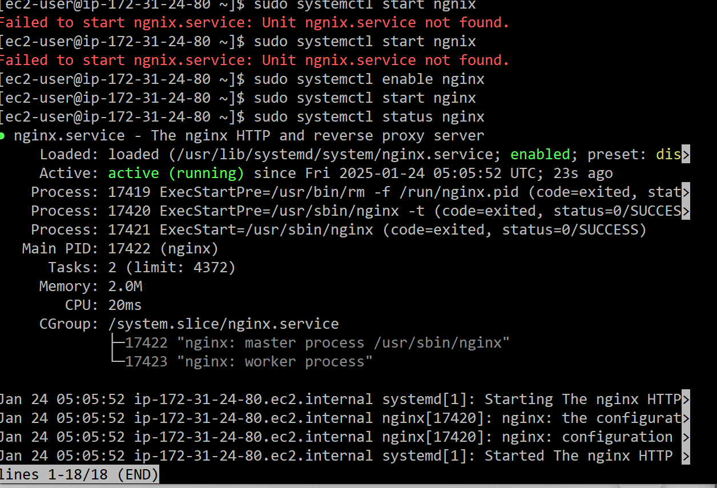
- Provide a screenshot of the web page displaying "Welcome to nginx!".
Screenshot: | 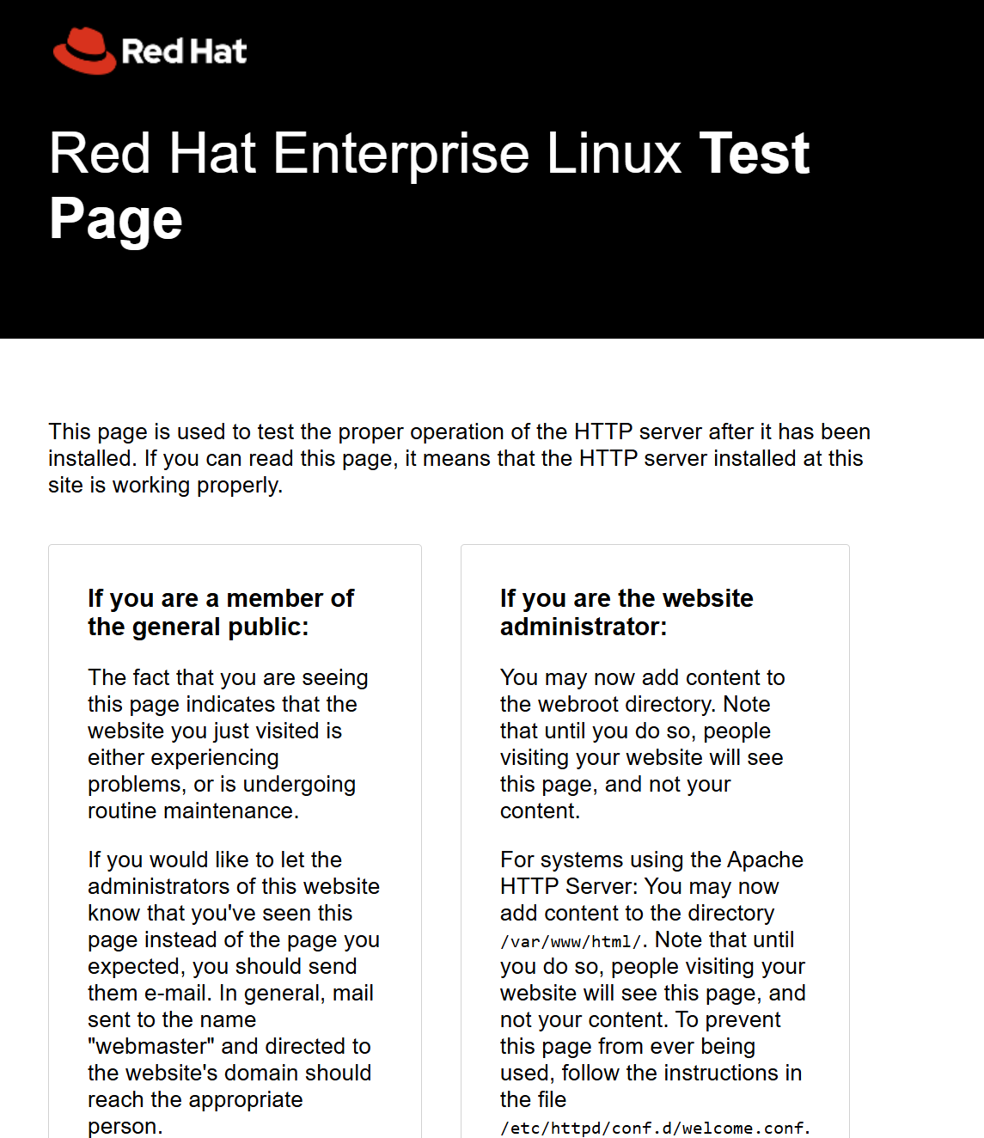
- Reflection
Reflecting on the exercises, think about how these Linux skills are essential in a DevOps role. Linux is the foundation of most cloud infrastructure, and the ability to manage servers, files, permissions, and networking directly impacts your efficiency and reliability as a DevOps engineer. What challenges did you encounter during these tasks? How do you think automating these processes could improve large-scale system management? Write a brief reflection on how mastering Linux commands can streamline DevOps workflows in real-world scenarios.
During this lab I found it to be easy to follow though towards the end I fear that I struggled with the nginx portion. It seems that I failed some part of that process because I did not see an “welcome to nginx” option on a web page. In following that instruction, I was only sent to the RedHat page online. I was a long assignment but thankfully each portion was so detailed. Though after reviewing the video given I found that I just need to read carefully.

